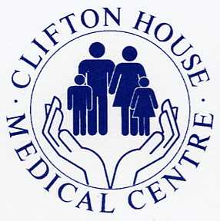

As from 1st July 2019 the practice can offer a limited amount of pre-bookable nursing, GP and nurse practitioner appointments on a Saturday morning to Clifton House Medical Centre patients.

The appointments will be available at Sydenham House Group Practice, Elliott Chappell Health Centre, Hessle Road, HU3 4BB. The clinician that you see will not be from Clifton House Medical Centre but will have access to your medical records.
Appointments can only be made through Clifton house Medical Centre
If you would like an appointment on a Saturday morning please speak to one of our receptionist who will advise on appointment availability.

